Eigenvector Radiosity - Corrigendum
Ian Ashdown, P. Eng., LC. FIES
byHeart Consultants Limited
March 25th, 2003
In Chapter 3, “Eigenvector Radiosity – Theory,” the diagonal elements of the conductance matrix (Figure 3.3) were interpreted as physical conductances. Because they were loop conductances, it was assumed that they had no net flow of radiative flux and hence had no effect on the radiative transfer equation solution. This implied that the diagonal elements of the approximate conductance matrix were unconstrained.
This interpretation was incorrect. Each node i instead represents a physical surface that diffusely reflects some of its incident flux back into the environment. Where the surface is concave, its form factor F_{ii} is non-zero because the surface can “see” itself.
The surface has reflectance ρ, which represents the portion of radiant flux that is reflected for a differential area of the surface. However, this does not represent the effective reflectance of the entire surface element.
The radiant flux balance for each reflection is:
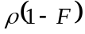 reflected away from surface
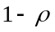 absorbed by surface
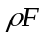 interreflected to surface
which means that the effective reflectance due to the infinite series of interreflections between the surface and itself is:
Using the geometric series expansion:
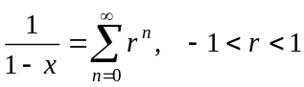
we have:
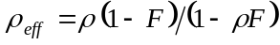
As the form factor F_{ii} increases from zero to unity, the effective surface reflectance 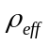 tends to zero, as we would expect.
In terms of network theory, this behavior can be represented by modeling a concave surface as an amplifier with positive feedback, and whose gain without feedback is 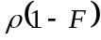. The loop conductance then becomes the feedback path between the output and input ports.
Alternatively, recalling that 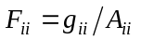each surface reflectance ρ can be replaced with the corresponding effective surface reflectance, in which case the diagonal elements of the approximate conductance matrix become zero.
With this, it can be seen that the value of the loop conductance determines the effective surface reflectance and so affects the radiative transfer equation solution.

